**Introduction**

Infants and children in the early years of their life need special care. During this period, one of the important and strenuousprocedures for childcare is bathing the baby. There are many and various doctor's recommendations, how to bathe the baby. Most experts agree that the main requirements are: to limit the time baby bathing and to keep the water temperature at the same level from the beginning to the end of the bathing. Typically, the mercury-in-glass or digital thermometers are used to control of the water temperature. In both cases, parents have often distracted to make sure the reading is at normal. It makes the process of bathing the baby more difficult for parents. Then, as one would pay more attention to the baby and not worry about breaking the rules baby bathing. Time interval for bathing the baby monitor in different ways: simply looking at clock, or by a timer. Again sometimes need a distraction, glancing at the clock and also remember the time interval bathing baby. If the timer is used, then not need to memorize the time, but there is another problem – bath time interval must be changed with the growth of the baby. It's may also cause difficulty for parents as they can simply forget about that at some particular day they need to bathe the baby more or less time. A special baby bath for bathing with a built-in digital thermometer and color display is one of the most common solutions to assist in the bathing of baby. Such baths are [comfortable](http://www.lingvo.ua/ru/Search/Translate/GlossaryItemExtraInfo?text=%d1%83%d0%b4%d0%be%d0%b1%d0%bd%d1%8b%d0%b9&translation=comfortable&srcLang=ru&destLang=en) because the baby can be put on the section with backrest and do not need to hold baby in hands. Still, it's are not very practical, because the small size of the bath allows parents to use it is not long, just a few months after the birth of a baby. When the baby is growing up, he (she) continues to bathe in a deeper and larger in size bath. Usually it is a simple plastic baby bath tub or typical bath for adult. Many of the parents bathe the baby in a large bath starting from the beginning, gently holding him until baby can be inside the tub without assistance. Water is cooled longer in sizeable bath. Also such bath is more practicable, because can be used for whole period of growing baby.

Ours analysis and watching of the features baby bathing has aroused a desire to help parents. It became the motivation for us to create a device capable of greatly simplify the procedure of bathing the baby. We decided to make the device (assistant in bathing the baby), which would be: for parents comfortable and practicable; for a child - harmless and interesting; for the family budget - relatively cheap.

**System design**

We had decided to implement a portable device with a view to ensuring practicabilityand versatility. First of all, it means without any integration with bath. In our opinion, a good solution is a device in the form of a ball, which can also serve as a toy for a baby. Therefore, the main system requirements were a waterproof (hermetic) and a self-powered. It is desirable that the housing of device was solid (or single) without any buttons, connector and other external elements. And the device holds to itself the tasks: be a thermometer and timer, adjust and control the time for bathing, notify parents about the violation of bathing process (temperature change, the end of bath time). A block diagram of the device is shown in Figure 1.

The device consists of three main parts: the [data processing](http://www.lingvo.ua/ru/Search/Translate/GlossaryItemExtraInfo?text=%d0%be%d0%b1%d1%80%d0%b0%d0%b1%d0%be%d1%82%d0%ba%d0%b0%20%d0%b8%d0%bd%d1%84%d0%be%d1%80%d0%bc%d0%b0%d1%86%d0%b8%d0%b8&translation=information%20processing&srcLang=ru&destLang=en) unit (DPU), the Input/output data units (I/O) and autonomous power system (APS). The (I/O) is subdivided into three parts: the module of turning on, a temperature sensor and a module of warning. The (APS) is subdivided into four parts: Lithium Ion Battery, the module of control charging, the wireless charging system, DC/DС Step-up voltage converter.

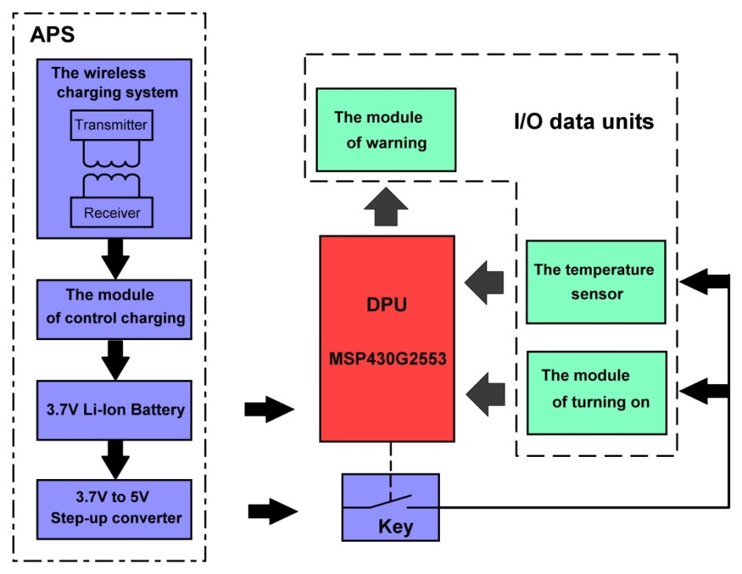

**Figure 1. Block diagram of device**

The (DPU) is a microcontroller MSP430G2553, which is great for the purposes of this project. First of all, because it ultra-low power consumption. It has a low cost and available in our markets. Also it has a 10-bit 200-ksps ADC with auto scan and enough ports (up to 24), which can be configured as Input or Output. In the device, the algorithm of the controller is a simple. The controller is activated by the signal that fed to one of the ports from the output the module of turning on. Over that time, to another port continuously comes signal proportional to the value of the water temperature in the bath. One more port is configured to output and connected to a module of warning, which give a light indication that water temperature is normal or not. Three colors signal the condition of the water temperature: normal it is green ([as a rule](http://www.lingvo.ua/ru/Search/Translate/GlossaryItemExtraInfo?text=%d0%be%d0%b1%d1%8b%d1%87%d0%bd%d0%be&translation=customary%20as%20a%20rule&srcLang=ru&destLang=en), it is temperature range 36 to 37o Celsius), the temperature change above the norm it is red ([as a rule](http://www.lingvo.ua/ru/Search/Translate/GlossaryItemExtraInfo?text=%d0%be%d0%b1%d1%8b%d1%87%d0%bd%d0%be&translation=customary%20as%20a%20rule&srcLang=ru&destLang=en), it is change on 1 or 2o Celsius) , if below the norm it is blue (it is the same 1 or 2o Celsius ). For such a module of warning there is no need to use display and look at the readings. The user only needs to respond to the color change and adjust the water temperature. For the user, it greatly simplifies the control of the water temperature, and for us it simplifies a hardware implementation. The module of warning had made also simply, is shown in Figure 2. It has 3 LEDs and 3 drivers of current that were implemented on bipolar transistors. Texas Instruments proposes infrared temperature sensors (for example TMP006 or TMP007) which can be good decision for non-contact measurements. But we decided not to use it because, is not clear how IR sensor would react to the color of housing. Also, in this case the temperature would be measured on the inner side of the housing and we would get more response time from sensor. That's why; in the bottom of the ball we had made a small area for a metal plate to which the inside of the ball should be tight contact with the chip of integrated-circuit (IC) temperature sensor LM35. IC temperature sensor slowly reacts to rapid temperature change in contrast with a thermocouple, resistance temperature device (RTD) or thermistor, but it is acceptable for our purpose. LM35 has an accuracy of Celsius, which satisfies the requirements for bathing baby. This choice has also other advantages. The first is easy to use due to the low output impedance, linear output, and precise inherent calibration. Also centigrade scaling, which is particularly useful for measuring water temperature. The second is that such sensor does not require any external calibration or trimming to provide typical nonlinearity of C at room temperature. For example, RTD requires an additional circuit of current source and the thermistor requires additional circuit of voltage source. Also, the thermistor requires linearity correction using series resistors. As for inexpensive thermocouple does not require excitation, but requires a lookup table in the controller to linearize the results. LM35 output (with C Scale Factor) is connected to one of the MC's ports, where with help the built-in 10 bit ADC signal proportional to the value of the water temperature is digitized and then is compared with values of norm and deviations above or below the norm. With 5V reference the FSR would be 5 and the LSB size would be , that is two times less than the required 10 mV and fully had satisfied us. Water tightness of the ball requires non-contact switching on the device. Wireless communication channels significantly complicate the implementation of the device increases the cost and harm to the child (unnecessary exposure). Therefore, to enable turning on the ball and run on the MC's algorithm was implemented a special the module of turning on. It is based on an accelerometer that responds to the shaking ball in any direction. We used accelerometer LIS332AR; it is available in our markets and has enough sensitivity. From the output of the module of turning on we receive impulses that bring to life the controller. To activate a MC the ball should be shaken 4 or more times per second. Then the device is started and the MC waits for the next command from the user. Next you need to shake the ball again. This command starts a timer, and the user puts the ball into the water. The MC's program takes into account sequence of user actions, first shaking (4 or more times per second) is activate the ball and second shaking (4 or more times per second) is run timer. Other combinations the program excludes. Also program provides protection from unnecessary shaking (or bumps) while bathing baby. It gives the baby an opportunity to play with the ball.

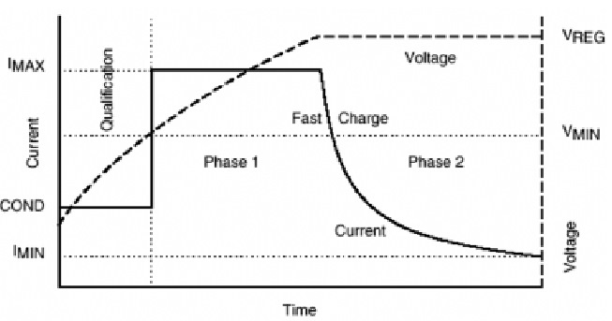At the heart of the autonomous power supply system (APS) is one-cell 3.7 V Lithium Ion Battery with internal protection from overheating. Choice the Li-Ion battery as a power supply allows increase the lifetime of the device and reduces the need for frequent servicing. Also due to its manufacturing technology such type of storage battery has a smaller size and weight than other storage batteries (as example NiCad or NiMH). The APS provides 3.7V for MC and module of warning and 5V to the module of turning on and to a temperature sensor. To provide 5V we used DC/DC Step-up converter based on MC34063, which connected to output of Li-Ion battery. Such a choice is cheaper for us, requires less external components, easy to setup and use. MC34063 converts at lower frequencies, which require large inductance value and size and more space on the board. TI proposes many good Step-up voltage converters with greater operating frequency (is orders of larger). But for the first prototype of our device, described features are not critical. For charging the Li-Ion battery we used the wireless charging system, which operates on the Qi standard. The wireless charging system consists of a transmitter, and coils system. TI proposes wide choice of chips that can operate on Qi standard for low-power inductive charging at different voltage supply. Also, on TI’s web site any one can find many great recommendations, applications and good description of how these chips work. For 3.7V Li-Ion battery the voltage 5V is a nearest value in list of available for Qi standard. Therefore, we focused on the 5V value. For build of receiver we had chosen chip bq51013 and bq500211 for transmitter. Li-Ion battery requires a constant current, constant voltage (CCCV) type of charging algorithm. In other words, a Li-Ion battery should be charged at a set current level (typically from 1 to 1.5 amperes) until it reaches its final voltage. At this point, the charger circuitry should switch over to constant voltage mode, and provide the current necessary to hold the battery at this final voltage (3.7 V per cell).Thus, the charger must be capable of providing stable control loops for maintaining either current at a constant value, depending on the state of the battery. To do this, we used the module of control charging, which based on chip bq2057. Bq2057 ensures that the charging process must match the curve in Figure 2. The main challenge in charging a Li-Ion battery is to realize the battery's full capacity without overcharging it, which could result in catastrophic failure. There is little room for error, only ±1%. Overcharging by more than +1% could result in battery failure, but undercharging by more than 1% results in reduced capacity. For example, undercharging a Li-Ion battery by only 100 mV (-2.7% for a 3.7-V Li-Ion cell) results in about a 10% loss in capacity. Since the room for error is so small, high accuracy is required of the charging-control circuitry. To achieve this accuracy, the controller must have a precision voltage reference, a low-offset high-gain feedback amplifier, and an accurately matched resistance divider. The combined errors of all these components must result in an overall error less than ±1%.The bq2057, combining these elements, guarantees the overall accuracy of ±1%, making it an excellent choice for Li-Ion charging.

***The module of turning on***

The circuitry of the module of turning on includes (or has) accelerometer with analog output, 4 order high pass filter with Sallen-Key topology, DC biasing circuit, Schmitt trigger, 1 order passive RC low pass filter.

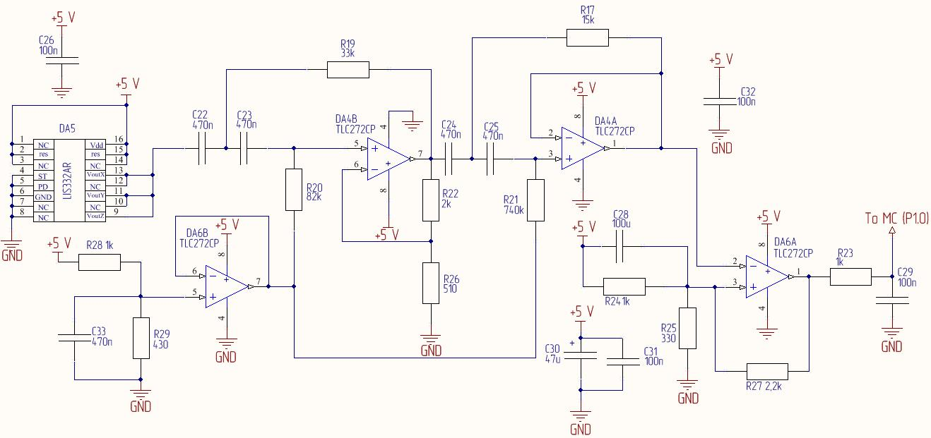

The main aim to design a high pass filter was to solve issue of MC's false positives (operations). It means that careful signals from accelerometer output are passed by filter because have higher frequencies than the corner frequency. At the same time another (“bad”) signals have less frequencies than the corner frequency and are rejected by the filter. We had determinate the corner frequency as 3 Hz. Careful signals are provided by shaking the ball by user (4 or more times per second). Sources of «bad» signals can be slow oscillations of water or jiggle in hand when user walking or etc. For provides better rejection in the stop bands we had designed 4 order high pass filter with Sallen-Key topology. For a steeper roll-off, 2 filter stages was (had) connected in series, making the filter more selective. First stage was calculated with 3 Hz corner frequency and a second stage with 4 Hz corner frequency. The Butterworth coefficients were used for calculate the filters function. We had laid out the board anticipating the possibility to vary the quality factor via the inner gain in the first filter stage. But, as result we have not used it and leave both filters’ stages with the unity gain topology. The characteristics of filter are shown in Figure 4. For frequencies less than 3 Hz, the roll-off is 90dB/decade. Signals at frequencies more than 3 Hz is passed with loss flatness. While, for example, the signals at 2 Hz are reduced by 30 dB. We had designed a single supply circuit; the lowest supply voltage is ground. For provide a symmetrical output signal, the potential of the non-inverting input itch OpAms in high pass filter is level shifted to 1.4V. We had used DC biasing circuit with buffer based on OpAmp, which used as a voltage follower and as an impedance converter. It is allowed not include the biasing circuit into the filter calculations. We used a Schmitt trigger for matching filter’s output signals with input of MC. It allows do not use typical and more complexity way to interface an accelerometer (as a sensor) with a MC. It means use an amplifier and inner ADC of MC. As a rule, output of comparator has positive or negative voltage supply level without any careful signal on input. We have considered this unpleasant feature in our circuit of Schmitt trigger. If you make analysis circuit at DC current you'll see that to the comparator’s inverting input comes 1.4V from DC biasing circuit. At the same time, at the non-inverting input set 1.24V by voltage divider. The output of the comparator goes to negative voltage supply, which connected with the ground. And on the output of Schmitt trigger we have a low level of logic “0” for MC (about 50mV) without any careful (AC) signals on comparator’s input. When the careful (AC) signals comes to comparator’s input the Schmitt trigger’s output generate impulses with high voltage level of logic “1” for MC (about 3.34V). The low threshold 1.3V provides noise immunity. First order passive RC low pass filter was added to the circuitry for reduce the level of high frequency component which we notice at the peak of impulses when were breadboarding.

We had chosen TLC272 operational amplifiers for all parts of circuitry. In all we needed in 4 Op Amps and were used in two dual packages. Texas Instruments offers a wide range of op amps in single supply applications. The reasons of choosing TLC272 are as follows:

1. It is low cost and available in our markets.
2. It is suitable for proper filter functionality. Firstly TLC272 can provide  for ﬁlter gain is +1 V/V and for adequate full power response. Secondly, there is wide input common-mode voltage range that limits the range of our input signal and also low input bias current because it’s CMOS amplifier. We are using the Sallen-Key ﬁlter conﬁguration; the input bias current of the ampliﬁer will conduct through resistor. The voltage drop caused by this error will appear as an input offset-voltage and noise source. And, if we have high input bias currents then must be used lower resistors in circuit. If do this, when must be increased the capacitors in order to leave ﬁlter cut-off frequency. Large capacitors are not a very good option because of cost, accuracy and size. Therefore, ﬁlter with lower corner frequency is requires a CMOS ampliﬁer.
3. The TLC272 had satisfied us as basis for Schmitt trigger to operate with a 5 V power supply. The TLC272 output voltage swing at = 5 V is 3.34 V (this is because of transistor saturation or cutoff), and this consistent with MC's input voltage ranges (it is  to  for logic “1”).

***The wireless charging system***

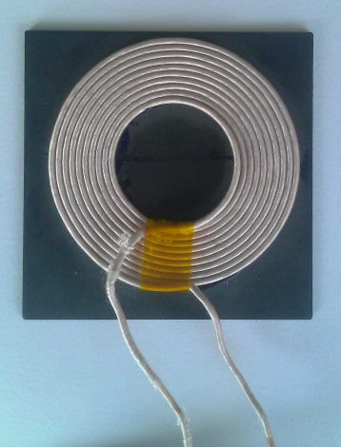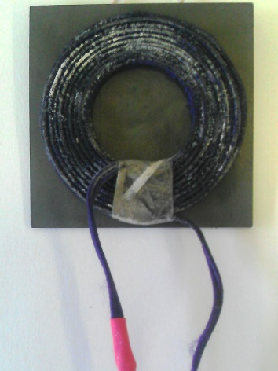 According to recommendations of Wireless Power Consortium (<http://www.wirelesspowerconsortium.com/downloads/wireless-power-specification-part-1.html> ) we had used type A5 Power Transmitter design. It has system of two coils, one is for transmitter and another is for receiver. For better efficiency of charging both coils (transmitter and receiver) is offered the positioning with help of neodymium magnets placing it in the center of each coil. Our experimental results showed that is enough power is transmitted without using magnets. But we still plan to keep it in the system. The magnetic field of magnets is less than 150 mT that does not disturb the field distribution between the coils. Coils are shown in Figure 5. Litz wire coils are wound to prevent skin effect. Both coils are placed on the ferrite plates. Firstly it allows increasing the efficiency because magnetic lines concentrated in a confined space. Secondly it is shielding from noise influence. For [resonance frequency](http://www.lingvo.ua/ru/Search/Translate/GlossaryItemExtraInfo?text=%d1%80%d0%b5%d0%b7%d0%be%d0%bd%d0%b0%d0%bd%d1%81%d0%bd%d0%b0%d1%8f%20%d1%87%d0%b0%d1%81%d1%82%d0%be%d1%82%d0%b0&translation=resonance%20frequency&srcLang=ru&destLang=en) (or operation frequency for wireless power transfer)  we get  in series and  in parallel

***The features of circuitry for decreasing power consumption*** 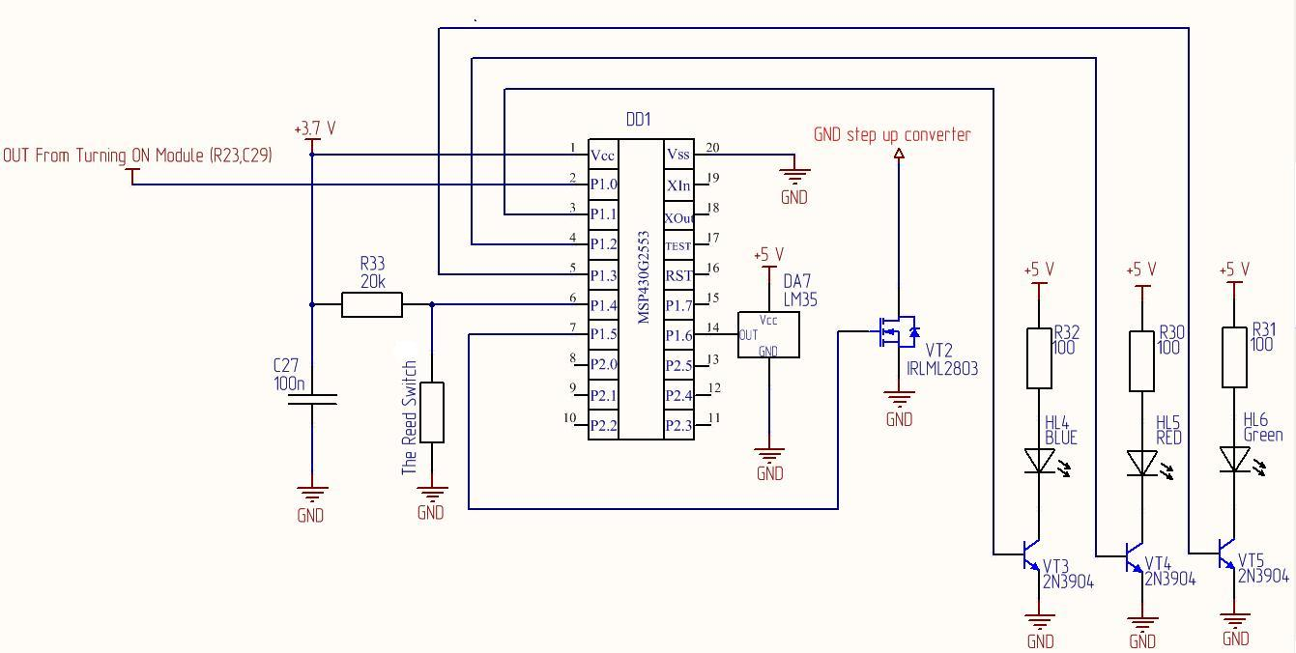

Figure

Since we used the magnets we added to the circuitry the reed switch. It is placed in parallel with the input port of MC where is applied voltage from the Li-Ion battery, as shown in Figure 6. When the ball put on the base station the circuit with the reed switch is closed and to the input port of MC comes low level of logic «0». Controller reacts for it. At another port of MC the transistor (at key mode) is opened by the high level signal of logic «1» and disconnects ground from parts of circuit with 5V supply. It is also shown in Figure 6. These schematics features are allow decreasing power consumption.

***The device*** [***composition***](http://www.oxforddictionaries.com/definition/english/composition#composition__3)

It is assumed that the device composition is as follows: the Ball and the Base station. It is shown in Figure 8. The top cover (that is lighting) is made of semitransparent white acrylic. Other parts of the ball housing are made of white non-toxic plastic. Base station must have a recess for locking the ball and indicator of charging. The radius of ball for our working prototype must be about 5сm to provide a buoyancy of housing. To calculate it we used equations:

; ,

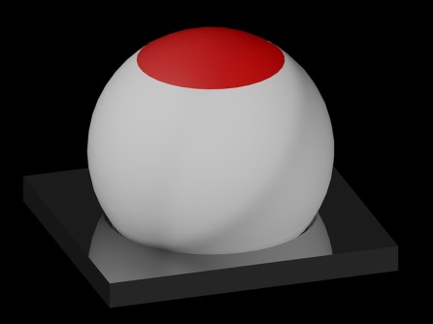Weight of ball , density of water , it is the volume of ball that is under water,  it is the volume of ball that is over water,  the radius of ball. We were calculated  for provide buoyancy of housing with  and.

Unfortunately, we have not yet made ​​a circuitry of a base station as we planned earlier. So we bought the device with a transmitter capable of working with Qi standard and were calculated for it the capacitance in circuit with coils. This is a temporary replacement were allowed to debug the working prototype.

**Experimental results**

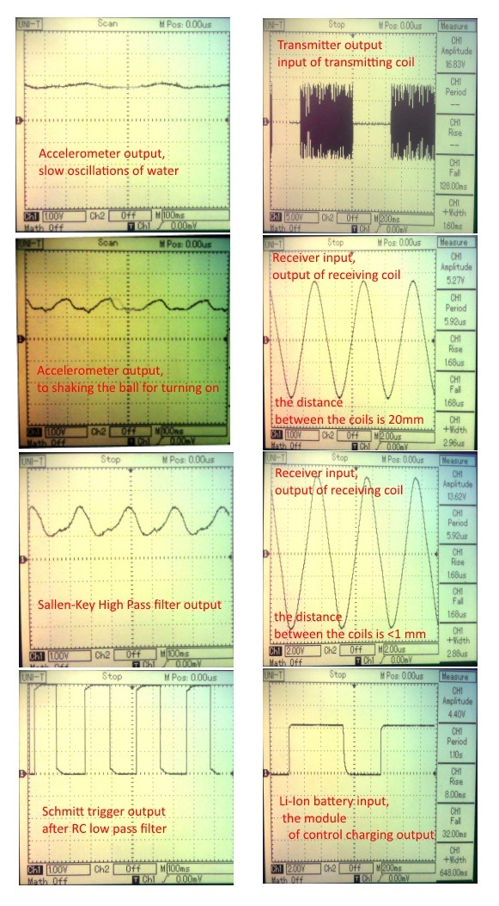

***Circuits***

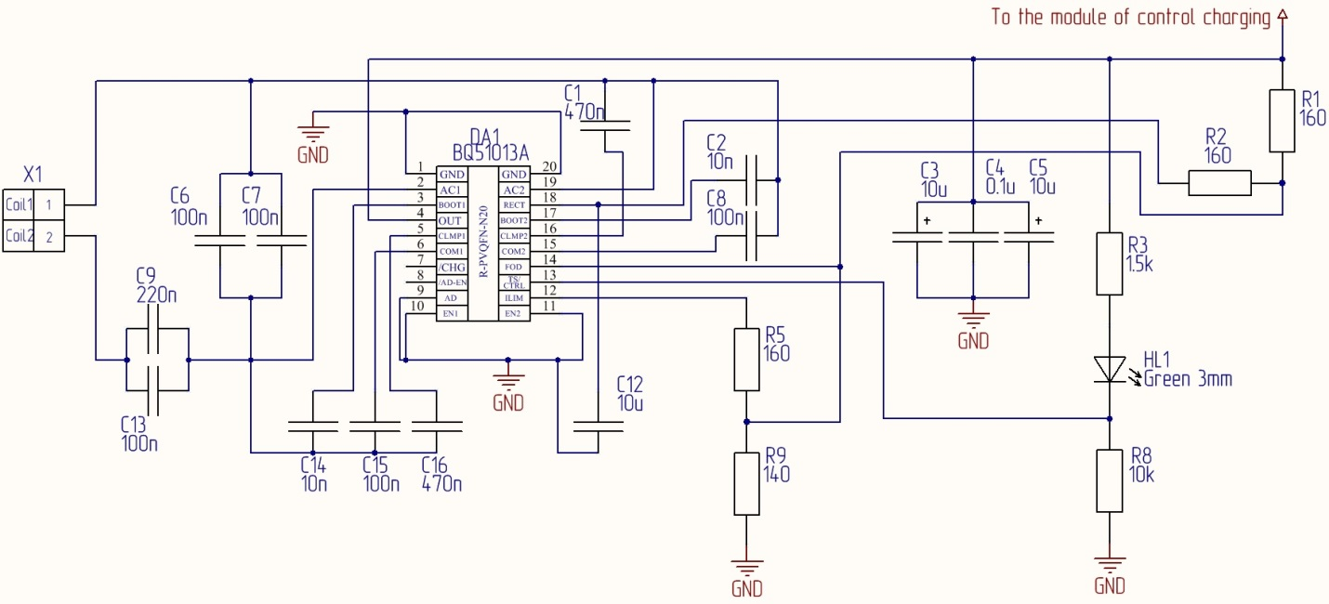

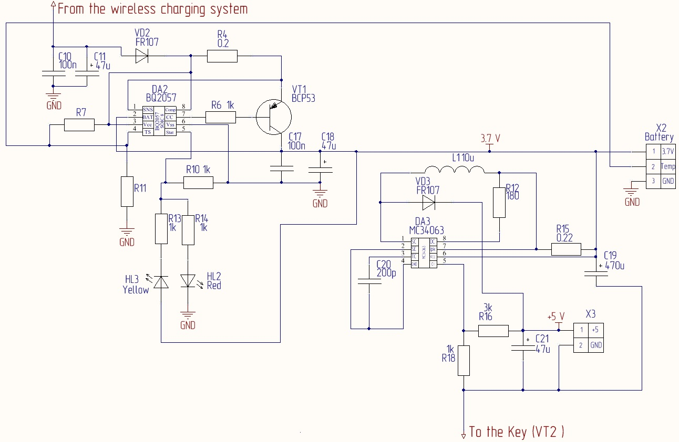

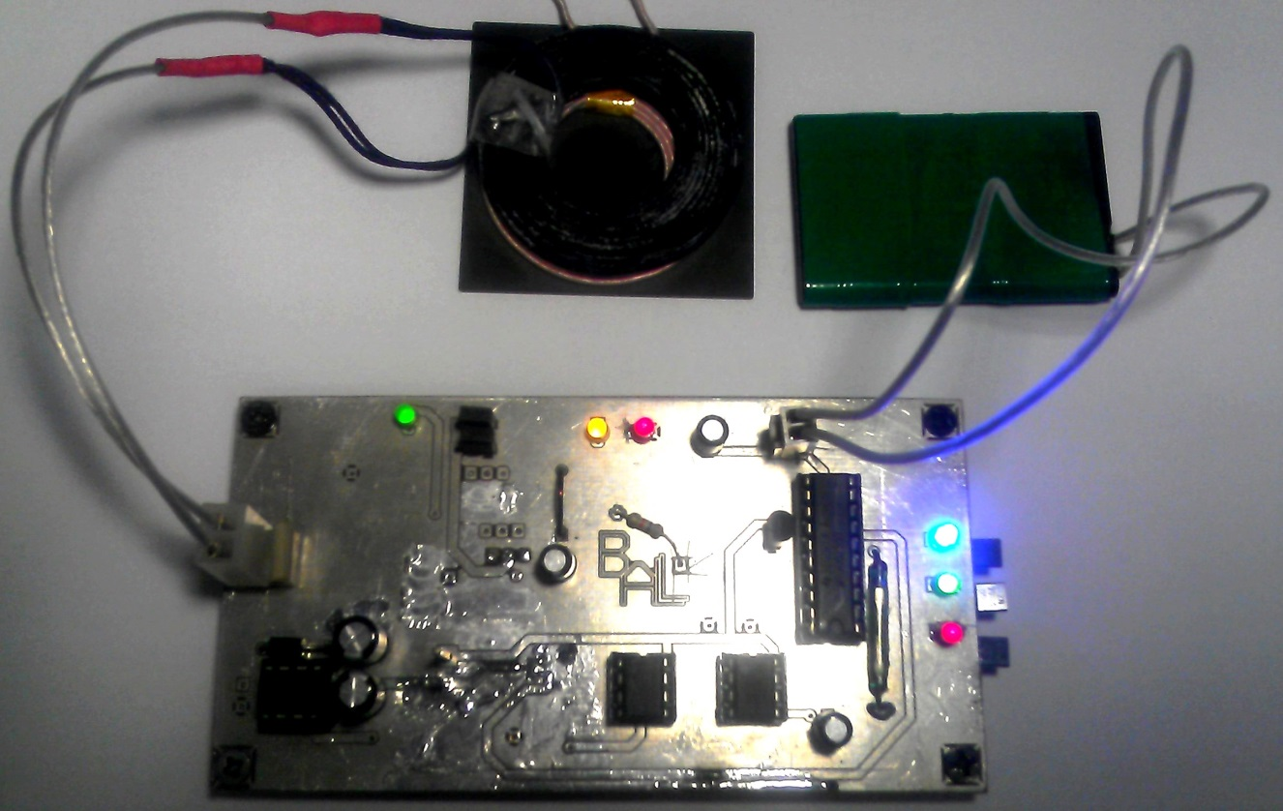

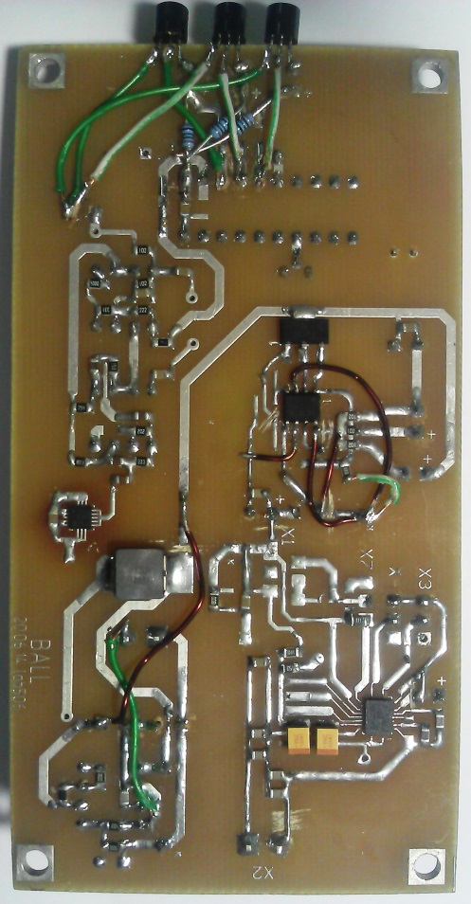

**Future plans**

Later we will make that the parents could own, easy and convenient to change the parameters of the device with a laptop. So they can always install bathing conditions as they want or by doctor's advice. Working prototype has parameters the bathing conditions that were wrote in МС firmware only one time. We are considering two ways to be able to change them: to organize data wireless connectivity with MC or to be able programming the parameters of bathing conditions by shaking the ball according to instructions. The first variant may be realized with adding [WL1271-TiWi-BLE WLAN 802.11 b/g/n and Bluetooth® v4.0 Module](http://www.ti.com/lit/gpn/wl1271-tiwi-ble). Also, we are planning to finish a designing circuitry of a base station: debugging of transmitter circuit based on bq500211 and to add an AC/DC converter to be able to feeding from 220V. We were disorganized when two of participants were unable to continue in the very beginning. We are very upset that did not have time to make all in time. But we are pleased with the results of their labor. And soon we will finish all that planned.

**Conclusions**

The working prototype of device shows good results and can prove concept of the project. It is turning on with shaking it and not reacts at any "bad" signals. Temperature is measured and the module of warning provides required color (red, green or blue). APS works and Li-Ion battery is charging about XX Hours.